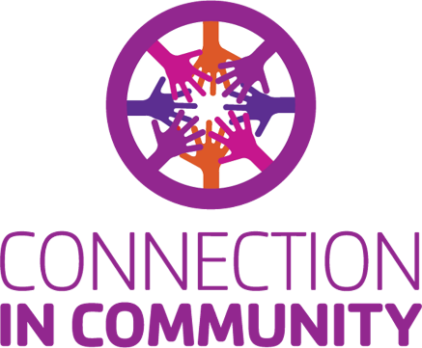
Date

Name
Company
Address
City, State Zip Code

Dear Name,

A healthy community is a connected community. Last year, thanks to donors like you, the YMCA of San Diego County provided over 198,000 direct scholarships – building important connections for those who need us most. Your support will ensure opportunities for all people, regardless of their background or their financial situation.

Can we count on your generosity for the 2025 Annual Campaign? Your gift of any amount will directly benefit kids and families right here in our own community.

Thanks to people like you, the Y will continue to be a resource far into the future. The enclosed brochure, “CONNECTION IN COMMUNITY” has more information about how your gift will make an important difference. THANK YOU in advance for your support of our YMCA and the people we serve.

Sincerely,

Campaigner Name
Branch Name YMCA Volunteer

